**Appendix A. Step-by-step Instructions to Perform Display QC Testing**

1. **Visual Inspection of Display Performance with Test Patterns**
   1. OBJECTIVE

* To ensure the mechanical integrity of the scanner display.
* To ensure the display performance is appropriate.
* To ensure the ultrasound image presentation on the scanner display is consistent with the ultrasound image presentation on the review workstation display
  1. TEST EQUIPMENT
* TG18-QA test patterns or equivalent.
  1. TEST PROCEDURE
* Check the scanner display cleanliness. Visually inspect the display surface for problems such as screen surface scratches, dust, fingerprints, and other marks that may interfere with clinical image viewing.
* Verify the system display configuration if the system allows the user to enable DICOM GSDF setting, as shown in one of the examples below:

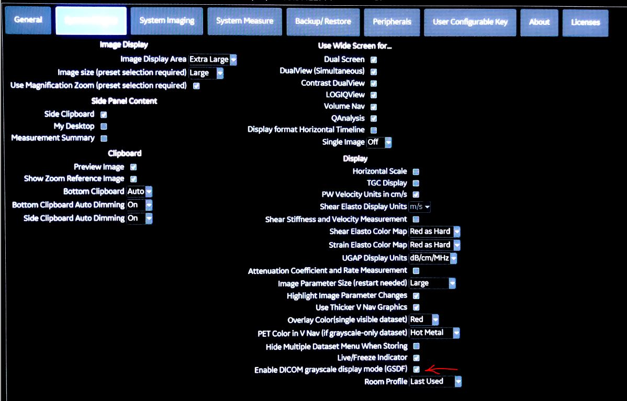

* Display the TG18-QC test pattern on the display monitor under the typical clinical viewing condition. Appendix B includes instructions for retrieving test patterns on some ultrasound scanners, such as the GE Logiq E10 and E9, the Philips iU22 and EPIC, Zonare’s ZS3, a BK 3000, and HitachiAloka, Canon Aplio, and the Handheld GE VScan systems. Not all the ultrasound scanner vendors provide the standard test patterns such as the TG18-QC test pattern. Some ultrasound scanners, e.g., BK and Canon Aplio, only provide vendor-specific test patterns. (Appendix B is posted online with the following link: .)
* Visually assess the following:
  + Is the 5% contrast patch in the 0% background visible?
  + Is the 95% contrast patch in the 100% background visible?
  + Are the two grayscale ramps smooth?
  + Are the characters of “QUALITY CONTROL” visible in the dark panel? Record the lowest contrast character observed.
  + Are the characters of “QUALITY CONTROL” visible in the gray panel? Record the lowest contrast character observed.
  + Are the characters of “QUALITY CONTROL” visible in the bright panel? Record the lowest contrast character observed.
  + Are there any visible artifacts?
  + For more advanced visual inspection, visually inspect the 16 luminance patches from darkest to brightest to determine whether the low contrast patches in the corners of each luminance are distinguished.

* Display the TG18-UN80 test pattern on the display monitor under typical clinical viewing conditions. Visually assess the following:
  + Are there small- or medium-sized, low-contrast, and irregularly-shaped patterns visible?
  + Does the luminance appear uniform over the entire display area (i.e., global uniformity)?
  1. PRECAUTIONS AND CAVEATS

If the scanner display surface needs cleaning, be sure to follow the manufacturer’s cleaning instructions. Do not use wipes or cleaning solutions that may damage the anti-reflective coating on the screen.

* 1. PERFORMANCE CRITERIA

The scanner display should be clean and free of significant marks that interfere with the visualization of ultrasound images.

The scanner display should be positioned with minimal interference from the reflections from any lights such as lamps, windows, or doors.

TG18-QC test pattern visualization should reveal the following:

* + The 0%-5% and 95%-100% contrast patches are visible.
  + Both grayscale ramps are smooth.
  + The characters of “QUALITY CON” are visible in the dark panel. Record the lowest contrast character observed.
  + The characters of “QUALITY CONTROL” are visible in the gray panel. Record the lowest contrast character observed.
  + The characters of “QUALITY CONTRO” are visible in the bright panel. Record the lowest contrast character observed.
  + The low contrast corners may not be visible in the darkest panel or the next darkest panel but should be visible in all the other luminance panels.

TG18-UN80 test pattern visualization should reveal no obvious artifacts, no significant local non-uniformities, and no global non-uniformity.

1. **Photometer Measurements of Display Performance**
   1. OBJECTIVE

* To quantitatively evaluate the luminance response function of the display.
* To verify GSDF calibration compliance.
* To assess the global uniformity of the display by measuring the luminance at multiple locations over the entire display.
  1. TEST EQUIPMENT
* A photometer. Below is a list of photometers utilized in the multi-institutional survey study described in Section 4:
  + RadCal Light Sensor: [https://radcal.com/light-sensor/](https://urldefense.com/v3/__https://radcal.com/light-sensor/__;!!MvNZe7V6M35iZPhbgng-hfU!yS_OeD0TjyIifHuENP1IhzlZKqJC5FlvQfJD51VMz3JjOLcl2L-Uc5hTKHl8I1FFRKbp0hXJorsRA1ECW7PhgA$)
  + Raysafe Xi Light Meter: [https://www.raysafe.com/products/x-ray-test-equipment/raysafe-xi](https://urldefense.com/v3/__https://www.raysafe.com/products/x-ray-test-equipment/raysafe-xi__;!!MvNZe7V6M35iZPhbgng-hfU!yS_OeD0TjyIifHuENP1IhzlZKqJC5FlvQfJD51VMz3JjOLcl2L-Uc5hTKHl8I1FFRKbp0hXJorsRA1Hi7D2Muw$)
  + Raysafe X2 Light Meter: <https://www.raysafe.com/products/x-ray-test-equipment/raysafe-x2/x2-light-sensor>
  + Extech LT300 Light Meter for ambient illuminance. Spectra Cine Candela Phorad III-R Luminance Photometer Model SC-810 for luminance. The resolution of the Phorad III-R Luminance Photometer Model SC-810 is 1.0 cd/m2 for the range of luminances used in diagnostic ultrasound imaging. This results in relatively large fractional deviations of the measurements from the GSDF for the low luminance levels. It is recommended that only measurements of the relatively larger luminance levels (e.g., > 10 cd/m2 ) should be used when assessing deviation from the GSDF.
* TG18-LN test patterns

2.3 TEST PROCEDURES

* Display the TG18-LN test patterns one by one on the scanner monitor.
* Measure the luminance values of each TG18-LN test pattern from -01 to -18 using a photometer.
* Enter the measured luminance values into the display QC Excel worksheet downloadable from: <https://tinyurl.com/US-Display-QC> .
* Measure the ambient illuminance at the surface of the scanner display. With the diffuse reflection coefficient provided by the manufacturer, the ambient luminance may be calculated.
* The 18 point luminance measurements and the ambient luminance are then used to calculate the contrast response function and verify the GSDF calibration compliance of the scanner display.
* To assess the global uniformity, display the TG18-ULN test pattern or a uniform image, measure the luminance at the center of the display and at the four corners and the four sides. The maximum luminance deviation can be calculated from these luminance values.

2.4 PRECAUTIONS AND CAVEATS

The ambient luminance may be measured by a telescopic photometer. If a telescopic photometer is not available, ambient illuminance may be measured and multiplied by the diffuse reflection coefficient provided by the manufacturer to obtain the ambient luminance value.

2.5 PERFORMANCE CRITERIA

For GSDF calibrated displays, the measured contrast response function should be within + 20% variation limits for each of the measured gray levels in comparison to the expected DICOM-GSDF contrast response function.

Display luminance uniformity may be inspected by calculating the maximum luminance deviation, defined as

2 * (the highest luminance - the lowest luminance)/ (the highest luminance + the lowest luminance)

The criteria for the maximum luminance deviation is 30%.

**Appendix B. Instructions To Retrieve TG18 Test Patterns or Vendor Test Patterns**

* GE ultrasound Logiq E9 and E10
* Philips ultrasound
* Zonare ultrasound
* BK ultrasound
* Hitachi ultrasound
* Toshiba/Canon ultrasound
* GE handheld: VScan
* Siemens Acuson S3000: Upload test patterns from a USB drive
* Siemens Acuson S2000/S3000: Retrieve test patterns in a local service mode

If uploading test patterns to the scanner display, precautions should be made that characteristics such as the matrix size and bit depth should be consistent between the scanner display and the images to be uploaded.

1. **GE ultrasound scanners: models Logiq E9 and E10**

Step 1: To pull the test patterns, go to the “Utility tab” on the touch screen of the console and click on “Test Patterns”.

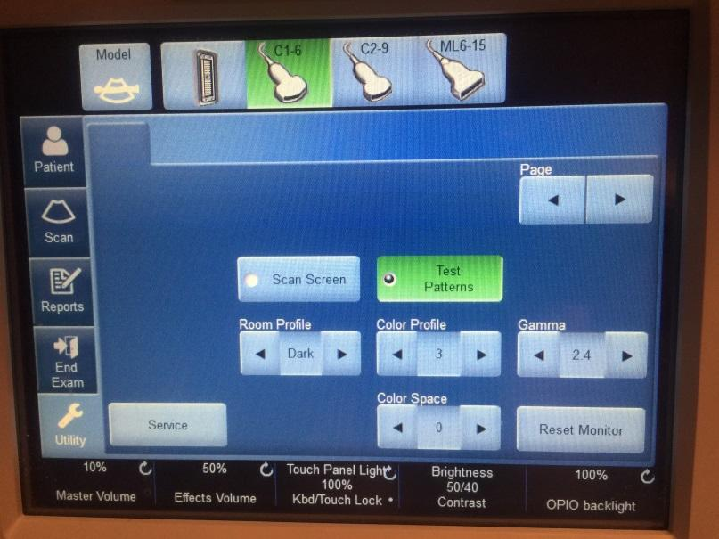

Step 2: A list of test patterns can be pulled from the list menu on the left of the screen. The TG18-QC test pattern is near the bottom of the list. No uniformity test pattern is available.

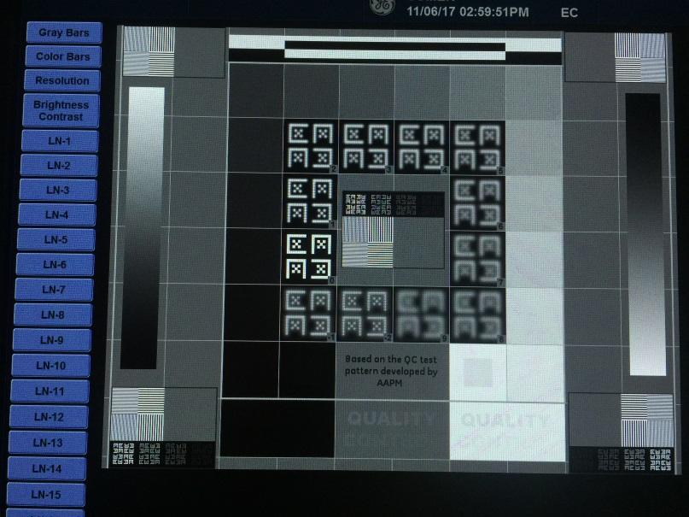

1. **Philips ultrasound scanners: models iU22, Epiq 5 and Epiq 7G**

Step 1: To pull the test patterns, go to the “Review tab” on the ultrasound scanner display

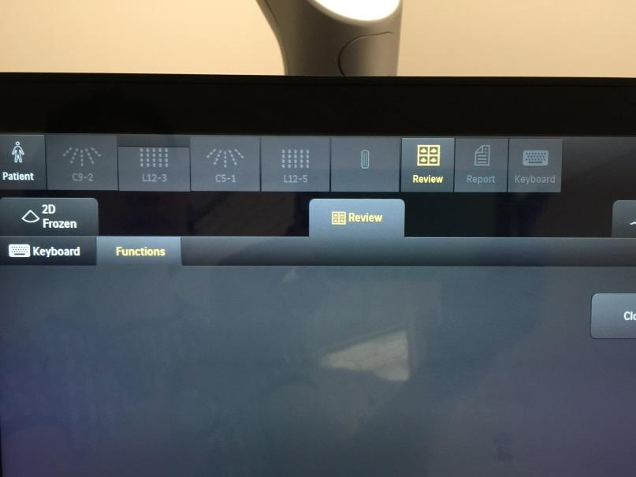

Step 2: At the upper left corner of the ultrasound scanner display, choose the “Source” from “Test Imgs”

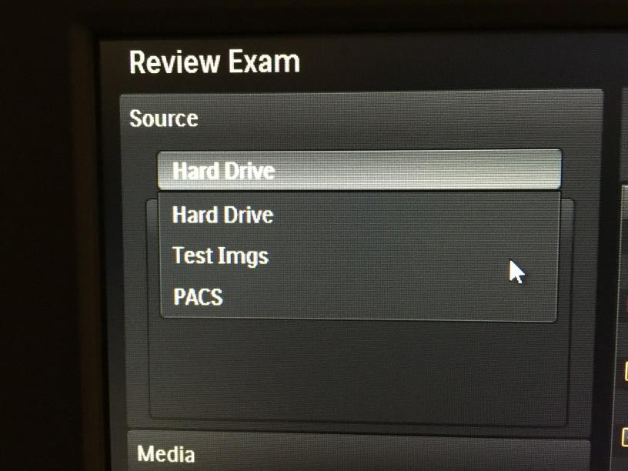

Step 3: A list of test patterns is available

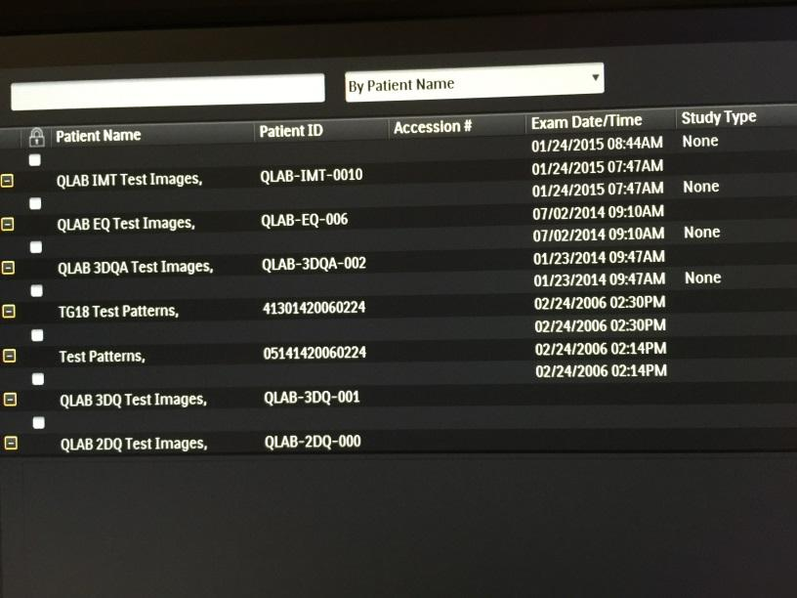

1. **Zonare Ultrasound Scanners: Model ZS3**

This system does not provide standard test patterns such as the TG18-QC test pattern.

Step 1: To pull the test patterns, press the “Setup” button on the console

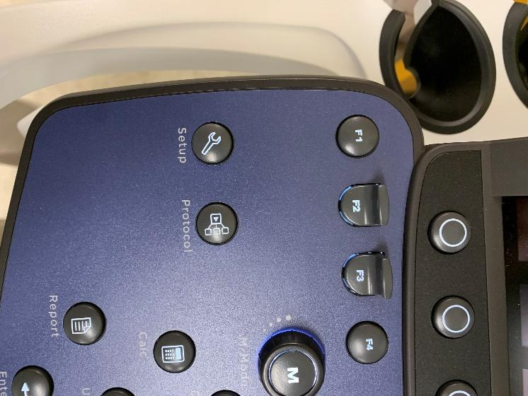

Step 2: Select “System Setup”

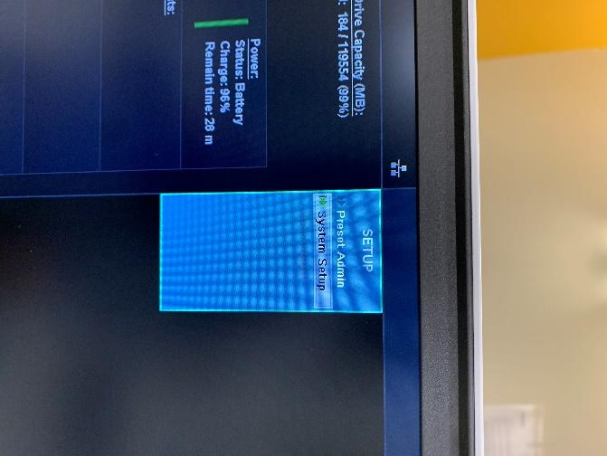

Step 3: Select “Display”

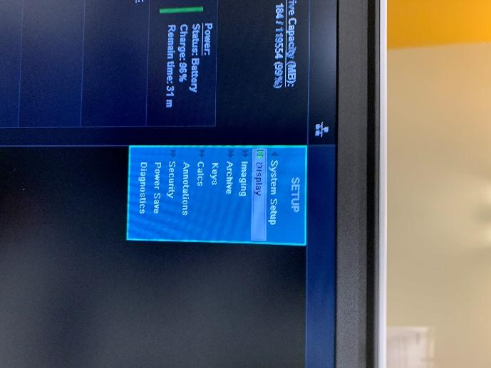

Step 4: Select “Bar Pattern”

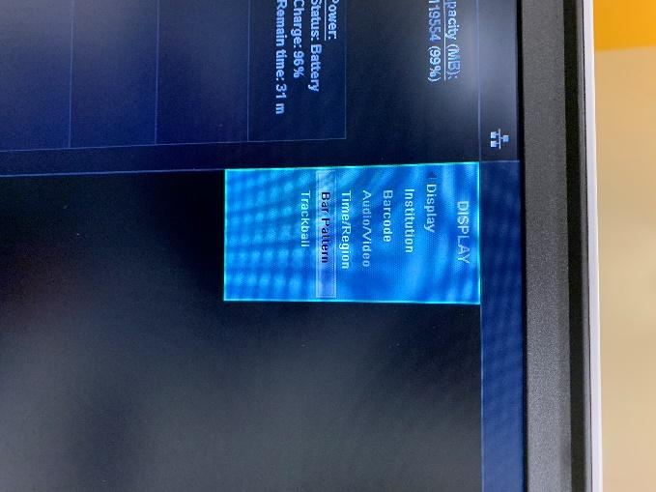

1. **BK Medical Ultrasound Scanners: Model bk3000**

This system does not provide standard test patterns such as the TG18-QC test pattern.

Step 1: Press Alt + Shift + G on the keyboard

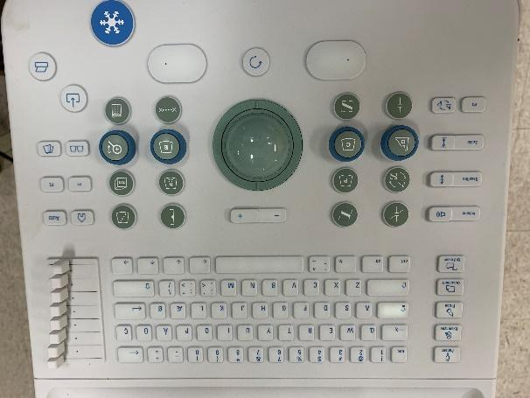

1. **Hitachi Ultrasound Scanners: Aloka**

This system does not provide standard test patterns such as the TG18-QC test pattern.

Step 1: Preload properly formatted SMPTE patterns to a USB drive

Step 2: Insert USB drive into port on scanner

Step 3: Select “tool” from hidden side bar on the left in scan screen

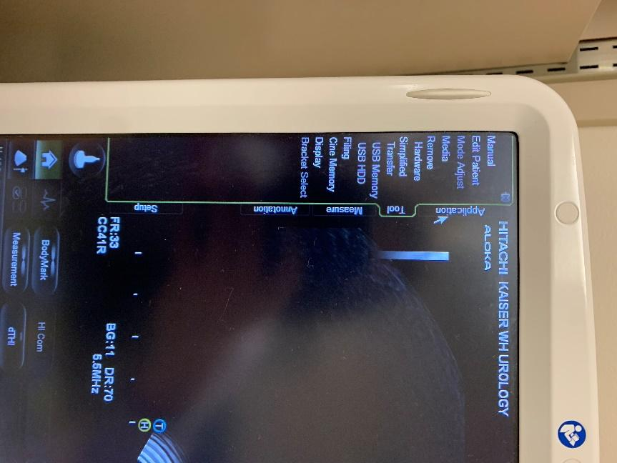

Step 4: Select “Media”

Step 5: Select “USB Memory” and open the appropriate file

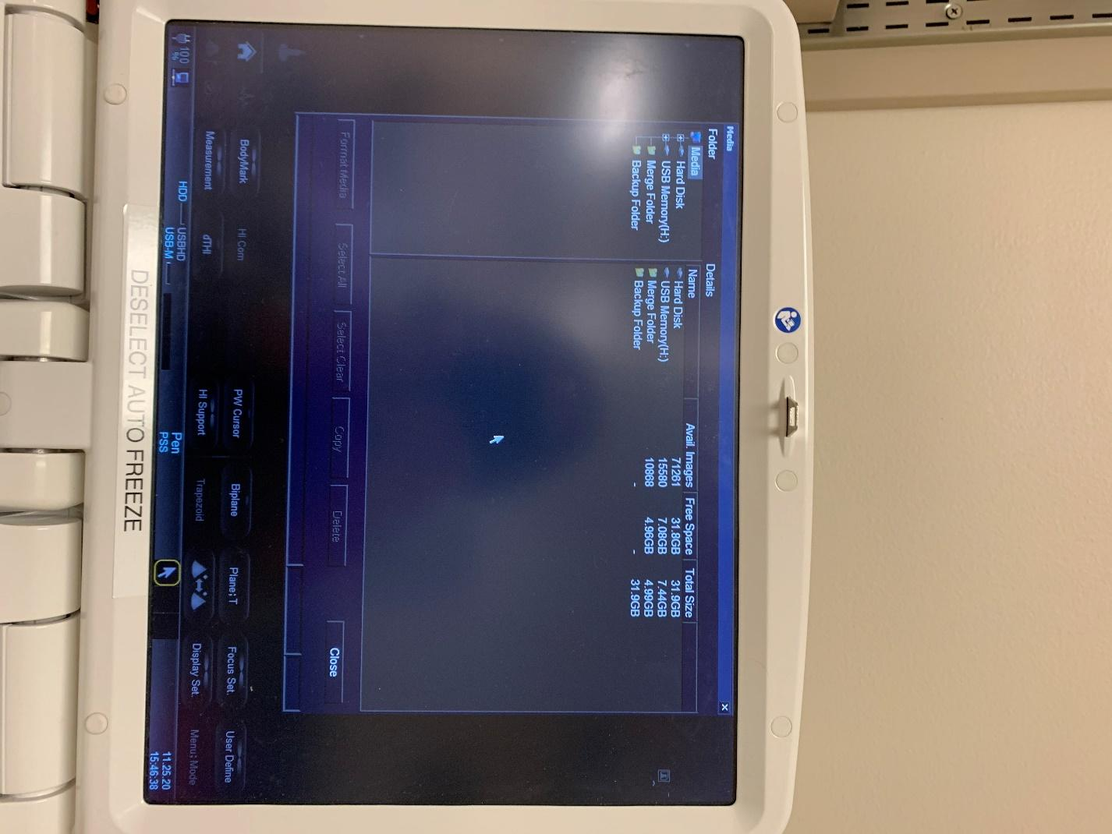

1. **Toshiba/Canon Ultrasound Scanners: Aplio i700**

This system does not provide standard test patterns such as the TG18-QC test pattern.

Step 1: Preload properly formatted SMPTE patterns to a USB drive

Step 2: Insert USB drive into port on scanner

Step 3: Open the patient browser by selecting the magnifying glass with folder soft key on the left

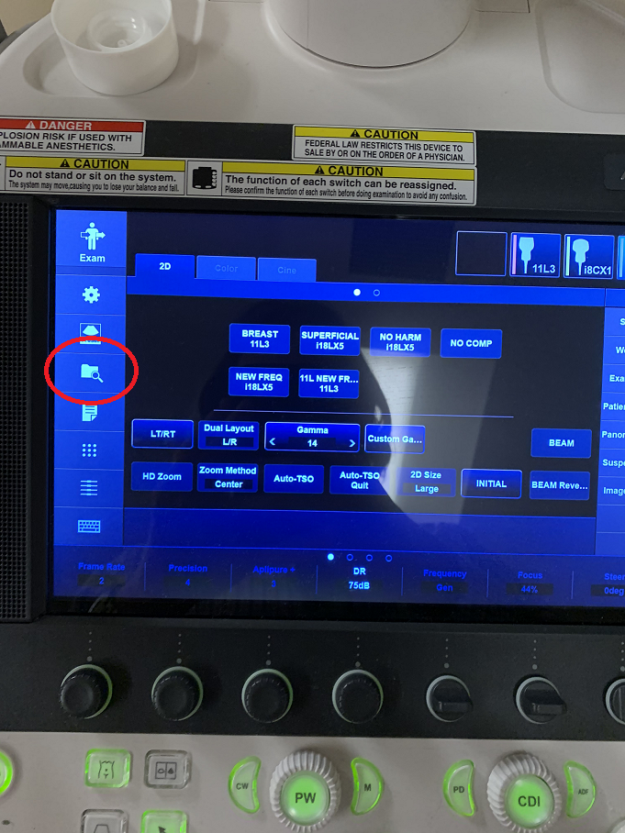

Step 4: In the top right “Location” menu, select “USB”

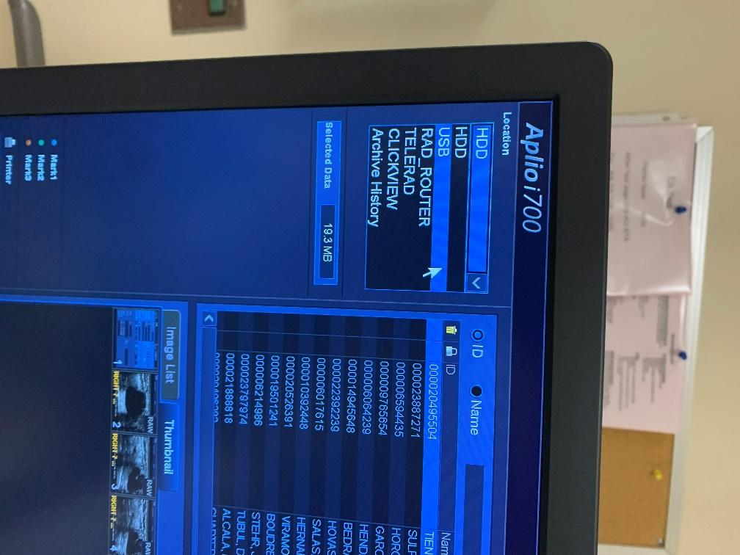

Step 5: Select the appropriate folder and click “Load to HDD” at the bottom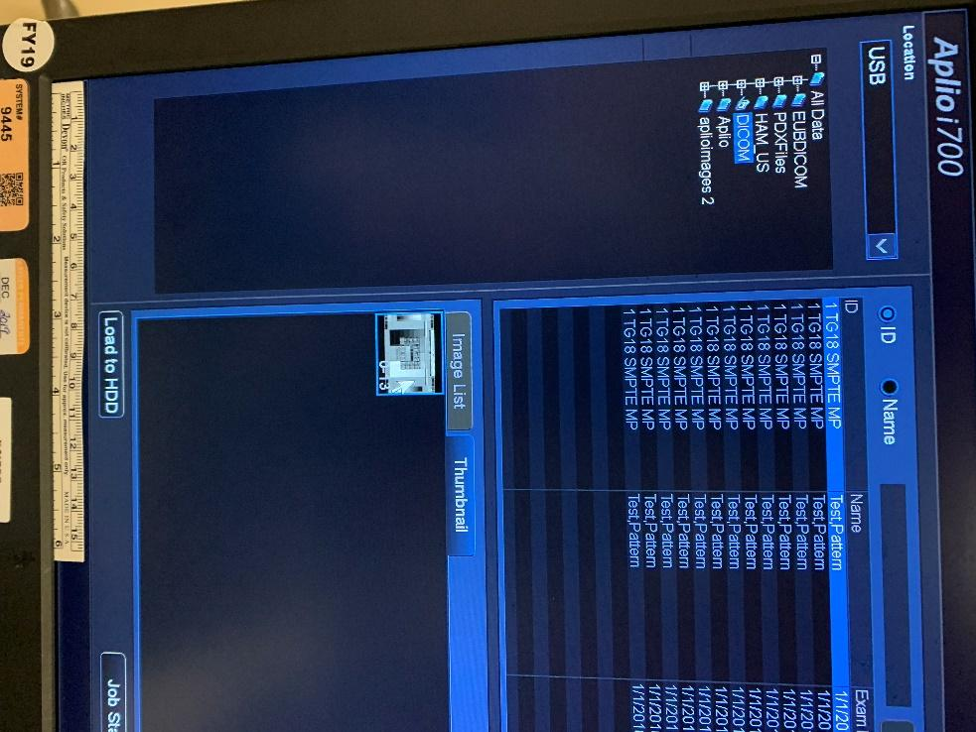

Step 6: Return to patient browser and select the appropriate “patient”. Double-click to open the pattern

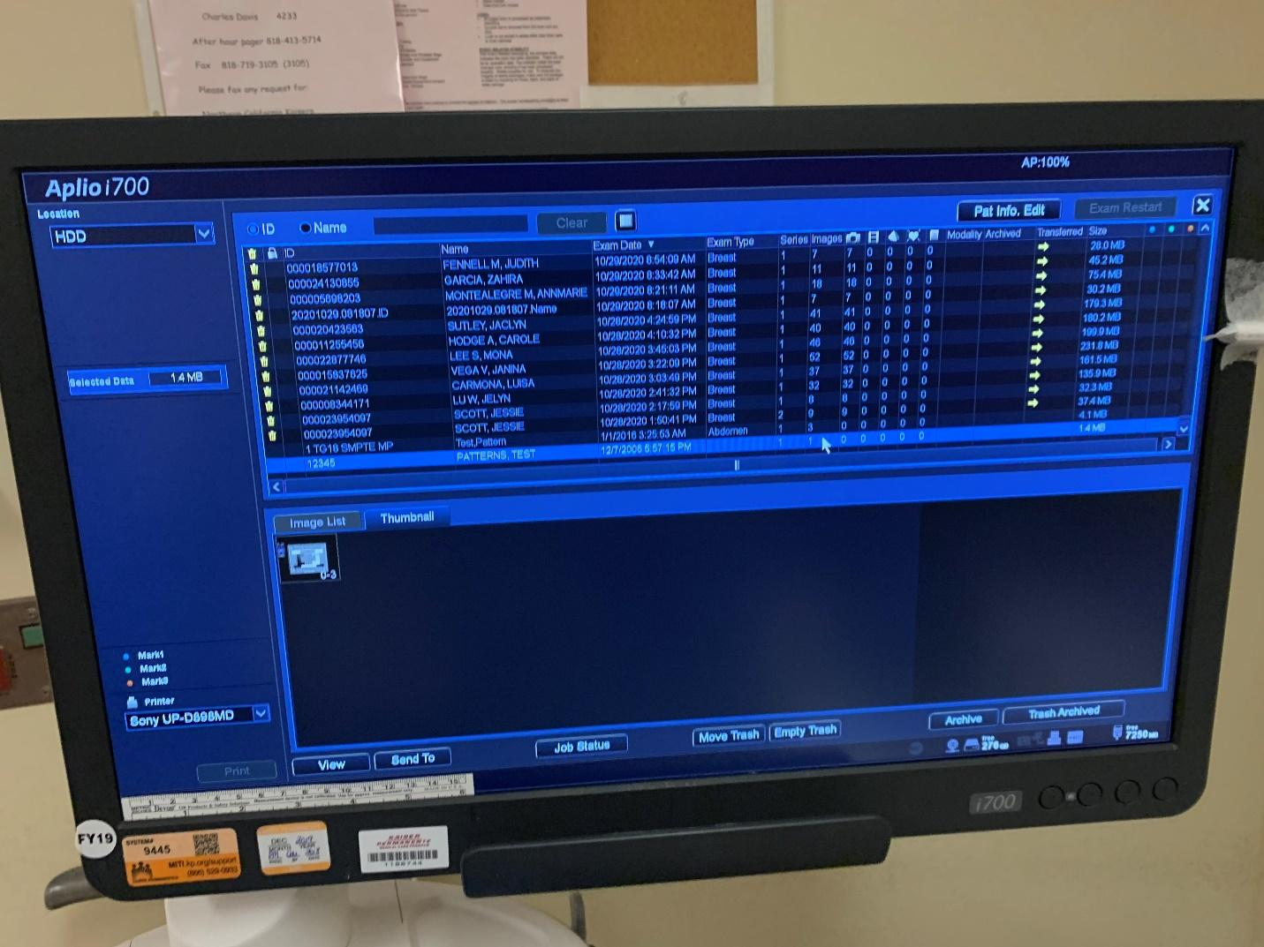

1. **GE Handheld Ultrasound Scanners: VScan**

Step 1: From the procedure screen, press the middle button

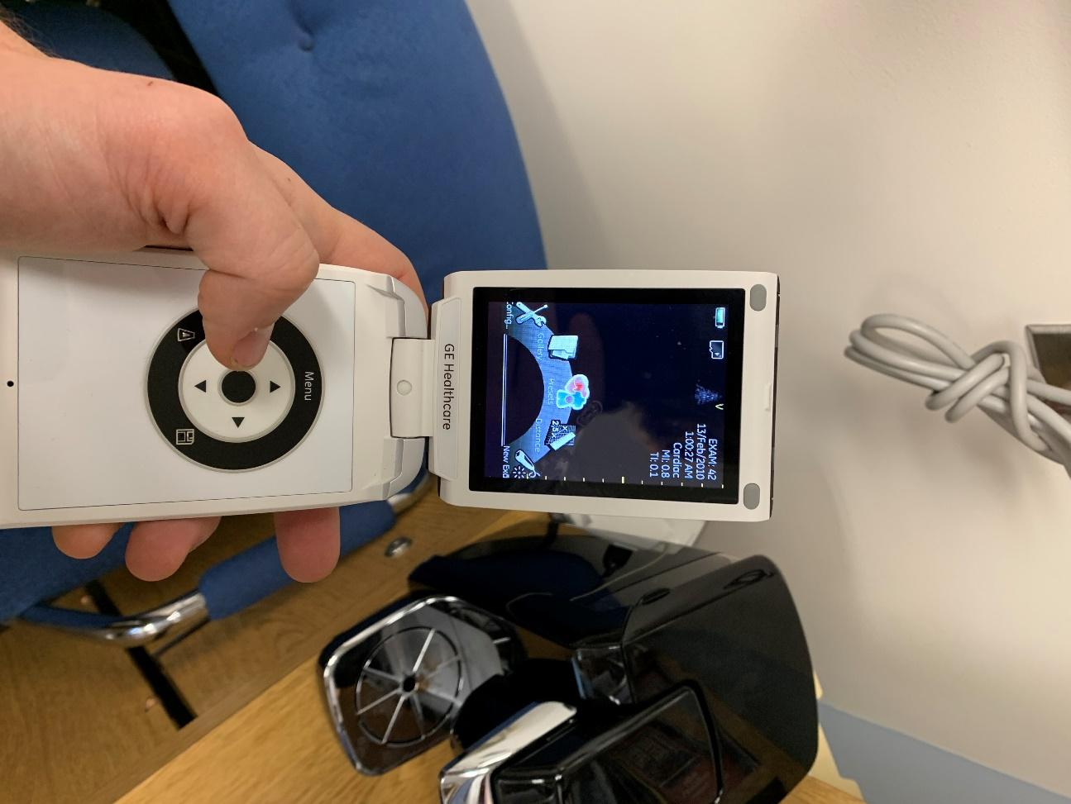

Step 2: Navigate with the arrow keys to “Config” and press the center button to select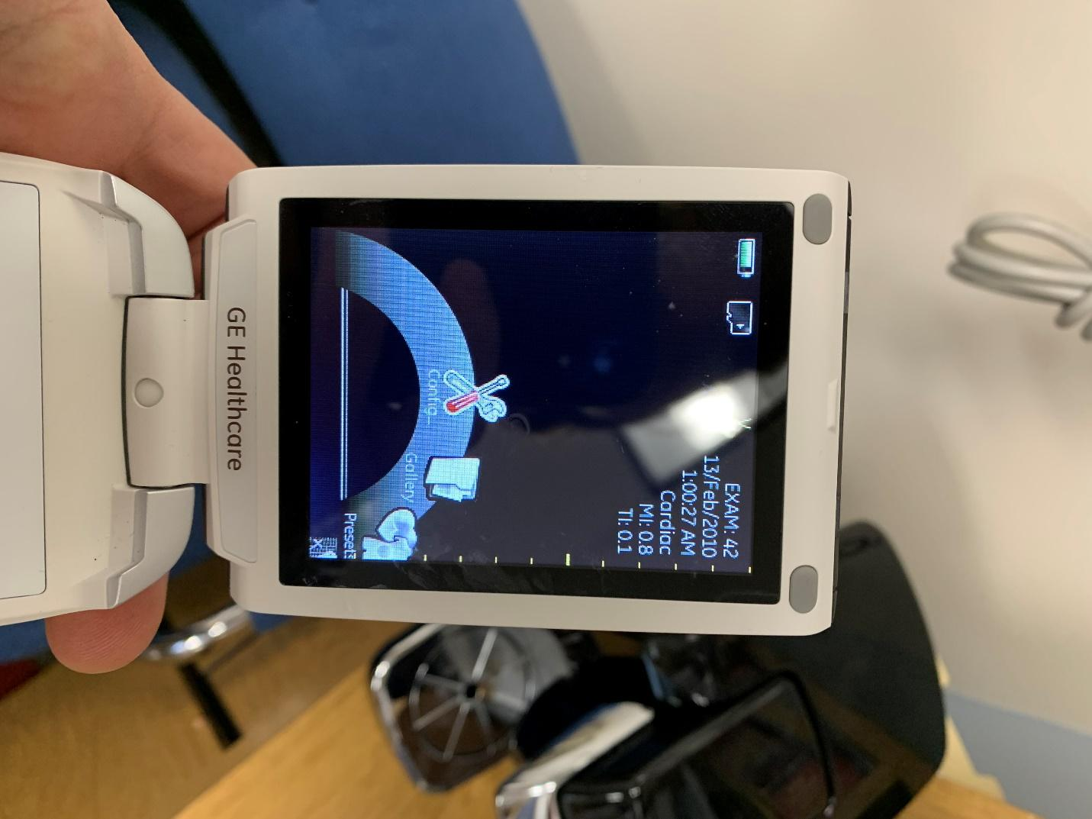

Step 3: Use arrow keys to navigate to “brightness” and press center key to select.

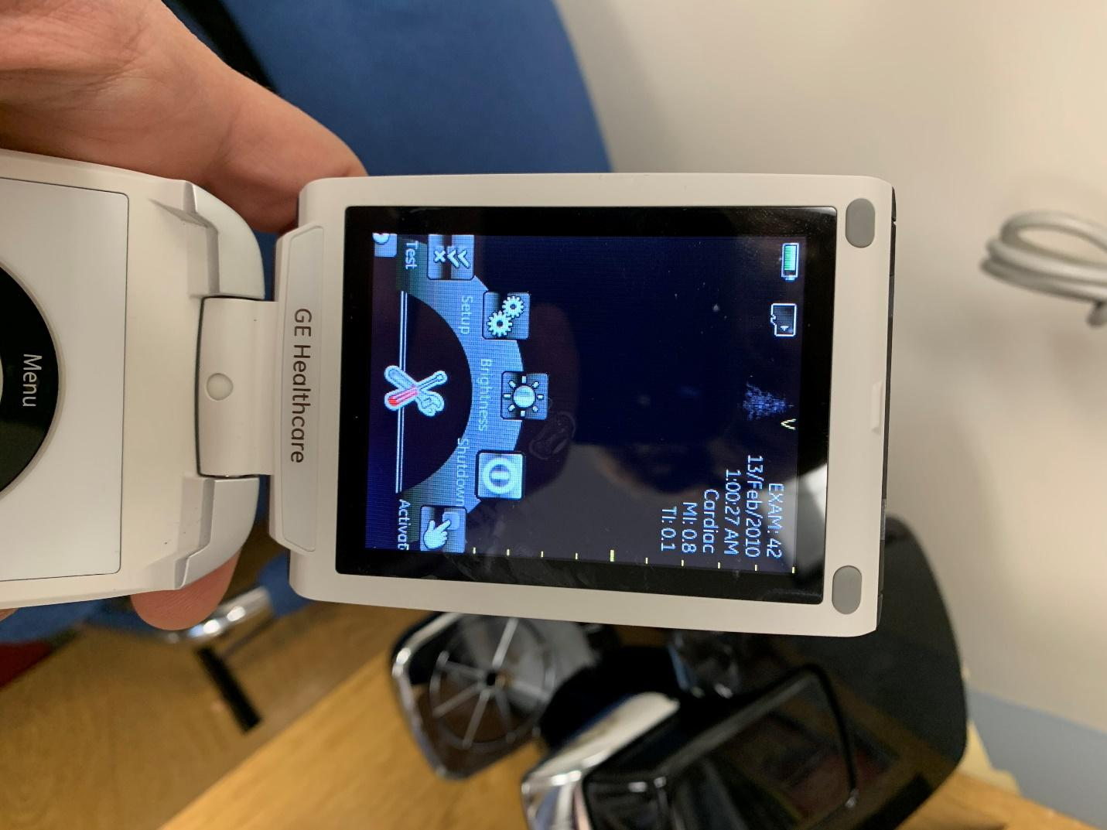

Step 4: You can adjust the brightness/contrast with the arrow keys to best visualize the pattern.

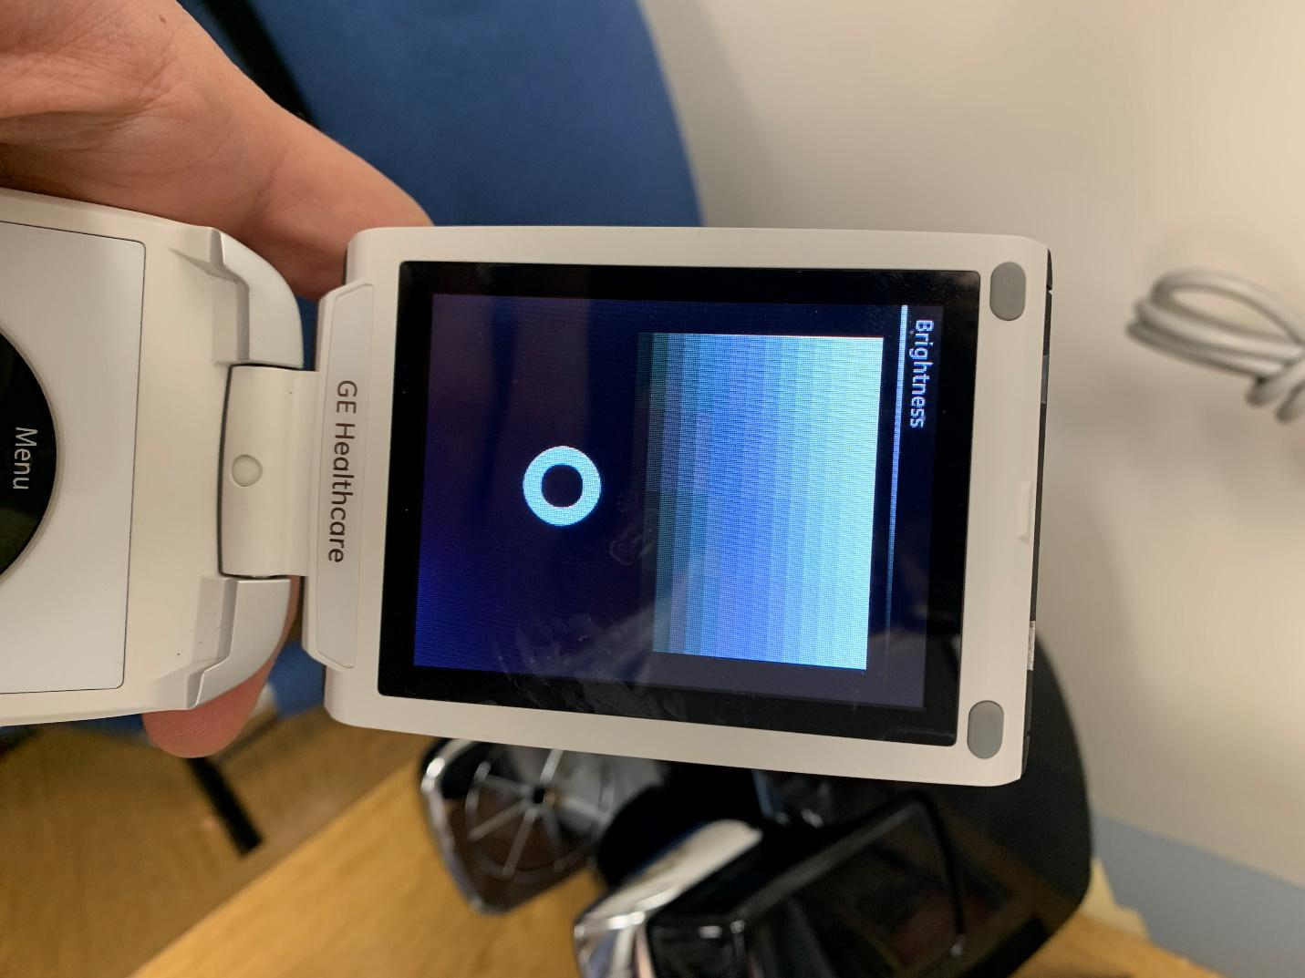

1. **Siemens Acuson S3000: Upload test patterns from a USB drive**

No TG-18 or SMPTE pattern was initially loaded on the system. The graphic interface of Siemens Acuson US unit is similar to other Siemens modalities (e.g. SOMATOM CT) that loading DICOM images is feasible via a USB drive.

TG-18 patterns can be downloaded from <https://deckard.duhs.duke.edu/~samei/aapm_tg18.html> and transferred to the portable drive.

1. Under “Patient”, select “Browser”

1. Under “Transfer” tab, select “Import from Off-Line”

1. Import TG-18 DICOM images from a portable drive

1. Review TG-18 Patterns for monitor testing

1. **Siemens Acuson S2000/S3000: Retrieve test patterns in the local service mode**

1. Click on the “Pointer” button shown below:

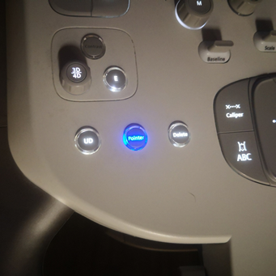

2. Move the trackball to the “wrench” icon and click on it (see the red box of the image below) and the “System Config” GUI will pop out:

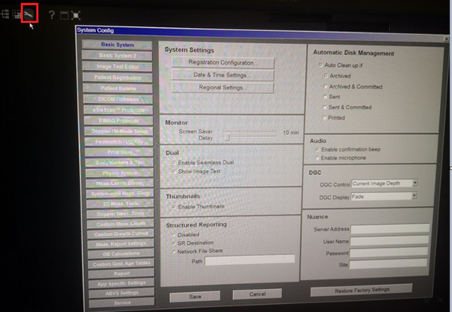

3. Click on “Service” at the lower left, then click on “Local Service…” under the “Service Options” at the upper right (see the red boxes of the image below):

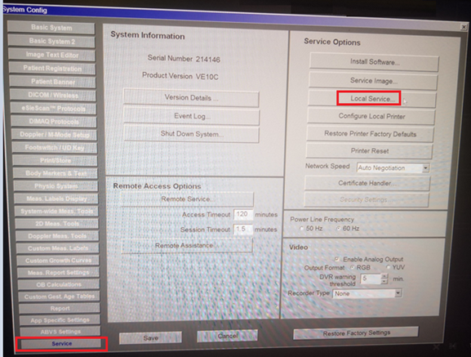

4. Now you see the pop-out window. There’s no need to enter a password there. Just click on the “X” and then click “OK” (see the red boxes of the image below):

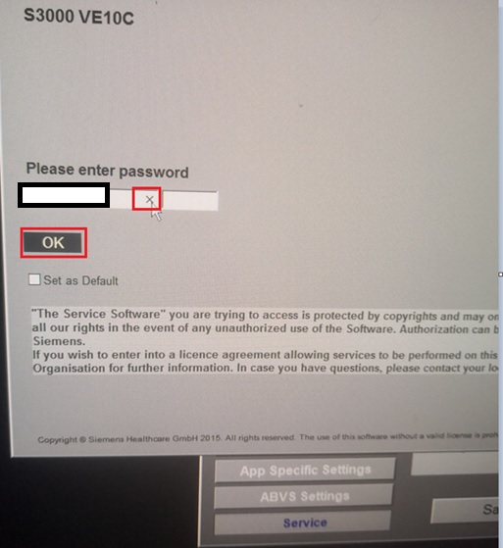

5. In the pop-out window, click on the “TuneUp” (see the red box of the image below):

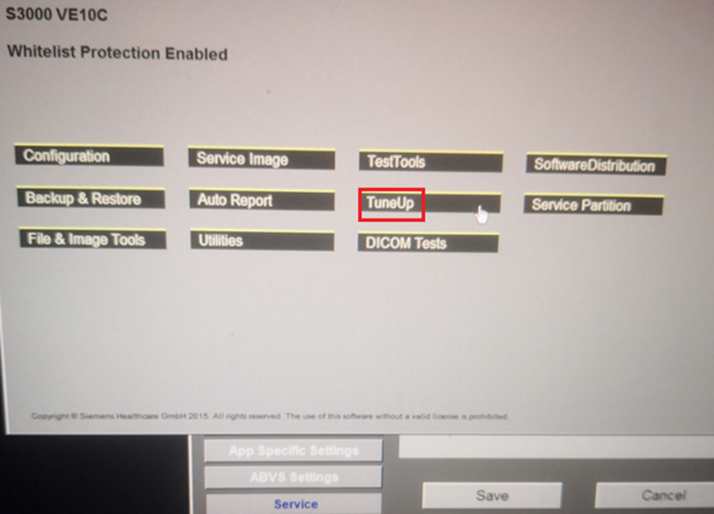

6. In the pop-out window, click on the “Monitor Patterns”, then click “TG18-QC 1920x1080” or other test patterns of interest (see the red boxes of the image below):

